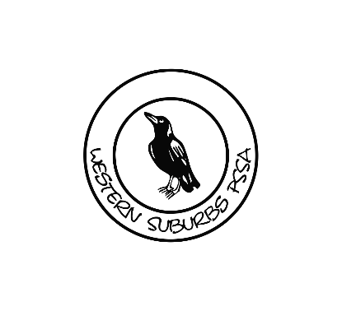

RED FLAGS: **Loss of conscious or deteriorating conscious state-Neck pain or tenderness Double vision- Weakness or tingling/burning in arms or legs-Severe or increasing headachesSeizures or convulsions-Vomiting Increasingly restless, agitated or combative** CALL AN AMBULANCE Inform Principal Call Incident and Support Hotline 1800 811 523

Return to Play

Medical review before returning to full contact training

Children 18 years or under - No return to contact/collision

activities before 14 days from complete resolution of all concussion symptoms

More complex sport-specific drills (24 hours)

No contact – no head impact

May add resistance training

Basic sport-specific exercises (24 hours)

No contact - no head impact

Return to Learn/Daily Activities

Children are not to return to play/sport until they have successfully returned to school without worsening of symptoms

Light aerobic activities (until symptom free)

48 hours physical and Mental Rest

Medical Assessment by Doctor within 72 hours to begin Graduated Return to Play (GRTP)

Signs and Symptoms emerge

Still no signs or symptoms – allow to return to sport but must be monitored for another 24 hours for any emergence of symptoms

Signs and Symptoms

Remove from activity

Observable Head Knock – No initial Signs and Symptoms.

24 hour Mandatory Rest (Head Injury Factsheet)

**Suspected Concussion**

Each step in the Graduated Return to Play (GRTP) should be a minimum of 24 hours.

Any recurrence of concussion symptoms, step back to previous step for minimum 24 hours and symptoms have resolved.

Recurrence of symptoms – Complete formal medical review

If not medically cleared, any further activity to be determined by medical professional

Full contact training (24 hours)